**Lab 05 Home Tasks (New Schema)**

**NAME:- YASH RAJ**

**ROLL NUMBER:- 24K-0737**

**QUESTION#1:-** **Write a query to display all columns from the employees table.**

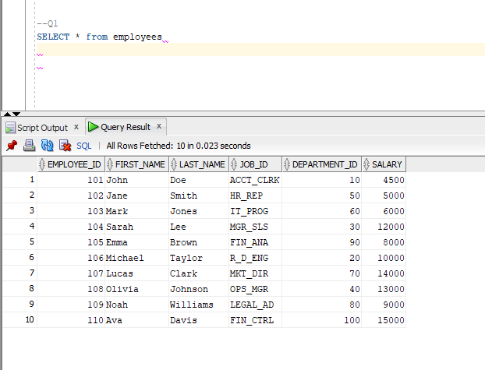

**QUESTION#2:-** **Write a query to display the details of employees whose salary is greater than 10,000.**

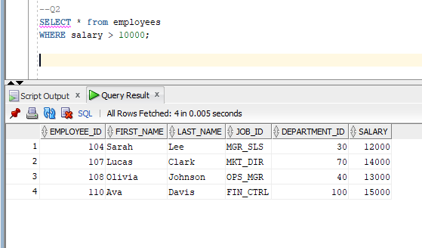

**QUESTION#3:-** **Write a query to increase the salary of &#39;John Doe&#39; (employee_id = 101) by 500.**

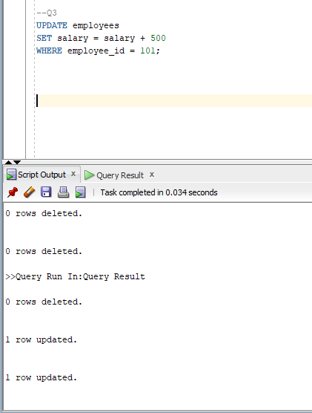

**QUESTION#4:-** **Write a query to delete the record of &#39;Olivia Johnson&#39; from the employees table.**

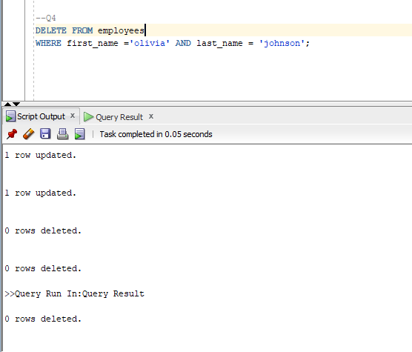

**QUESTION#5:-** **Write a query to display the first 5 employees from the employees table.**

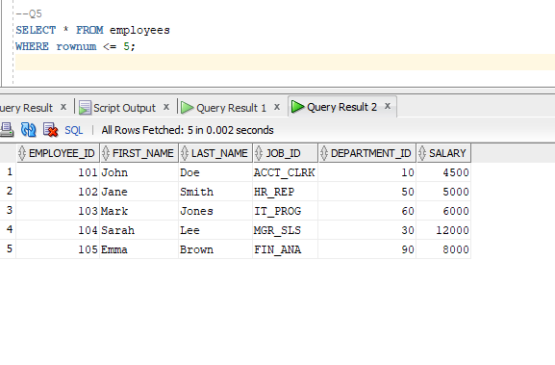

**QUESTION#6:-** **Write a query to add a new employee to the employees table with the following details.**

**∙ employee_id: 111**

**∙ first_name: &#39;Charlie&#39;**

**∙ last_name: &#39;Adams&#39;**

**∙ job_id: &#39;IT_PROG&#39;**

**∙ department_id: 60**

**∙ salary: 7500**

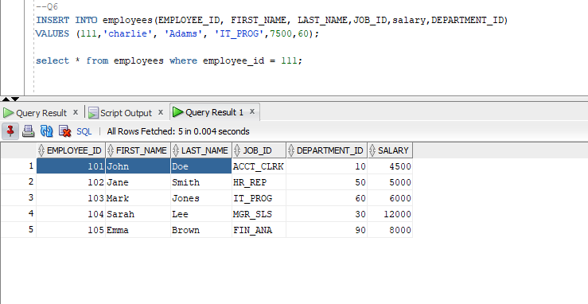

**QUESTION#7:-** **Write a query to display the first_name, last_name, and salary of employees, ordered by salary in descending order.**

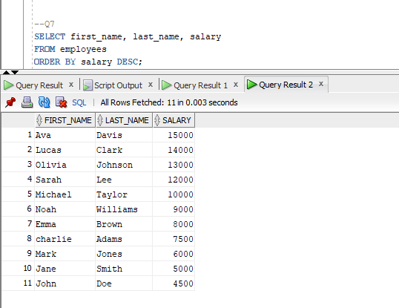

**QUESTION#8:** **Write a query to display distinct job titles from the jobs table**

